Autonomous Security Patrolling Robot with Motion Detection and Machine Learning

Mahajan Pritesh Haresh   
Electronics and Computer Science  
SIES Graduate School of Technology  
Nerul, Navi Mumbai, India  
[priteshhmecs124@gst.sies.edu.in](mailto:priteshhmecs124@gst.sies.edu.in)

Mhatre Jalmesh Sanjay  
Electronics and Computer Science  
SIES Graduate School of Technology  
Nerul, Navi Mumbai, India  
[jalmeshsmecs124@gst.sies.edu.in](mailto:jalmeshsmecs124@gst.sies.edu.in)

Murkute Siddhesh Mahadev  
Electronics and Computer Science SIES Graduate School of Technology  
Nerul, Navi Mumbai, India  
[siddheshmmecs124@gst.sies.edu.in](mailto:siddheshmmecs124@gst.sies.edu.in)

*Abstract*— This autonomous security patrol robot is fitted with thermal imaging, ultrasonic sensing, machine learning, and line-following navigation for continuous surveillance of 24×7. Mainly, the thermal camera acts as a primary long-range motion detector and helps in identifying the heat signature of humans or animals even in low or dark conditions, making it early detection. Two ultrasonic sensors mounted on a rotating servo provide 360-degree obstacle detection for confirming a physical object's existence before proceeding to visual verification; short range enables validation. During patrol, the robot follows a predefined line autonomously while detecting thermal anomalies. As soon as the robot detects a potential target, the ESP32-CAM spins towards the heat source and grabs an image of it before sending it to a cloud-based MobileNet model for human classification. Alerts and live video streaming on the website are provided only after confirming human sighting. Locomotion and short-range sensing are based on Arduino, while imaging and cloud communications are the role of the ESP32-CAM. By using this integrated multi-sensor fusion in a real-world environment, false alarms are reduced, and detection accuracy at long and short ranges are improved, increasing the overall reliability of the system when used for autonomous patrolling.

Keywords— Autonomous Robot, Thermal Imaging, Ultrasonic Sensor, Sensor Fusion, Machine Learning, Line Following, ESP32-CAM, Surveillance

# Introduction

Security systems are prone to continuous monitoring, reliable detection of intruder activity, and the ability to operate efficiently even under varying conditions within environments. The coverage of conventional, fixed surveillance cameras cannot adapt to dynamically changing incidents, while human patrols are labor-intensive, inconsistent in performance, and unsuitable for continuous operation. Mobile Surveillance robots offer a very practical solution by combining autonomous navigation with intelligent sensing to perform continued patrolling jobs. Recent advancements in embedded processors, thermal imaging sensors, and lightweight machine learning models have further enabled small robots to achieve a high level of situational awareness without a lot of human intervention.

This paper presents a mobile autonomous surveillance patrolling robot integrating thermal motion detection, ultrasonic obstacle sensing, infrared line following, and online machine learning for improving surveillance reliability. The robot is intended to patrol between predetermined tracks in line-following mode while continuously monitoring the surrounding environment for heat and physical anomalies. The main objectives of the system are the detection of possible intruders, confirmation of human presence in pictures through image classification, and notification in real-time via a web-based monitoring interface.

The hallmark of the proposed design is the MLX90640 thermal camera acting as the primary long-range motion detector. Unlike PIR sensors that rarely work with moving platforms-there's an 8×8 or 32×24-pixel heat map from which heat signatures will be detected on temperature thresholds occurring between frame-to-frame motion analysis. Because of this, patrolling at night is completely possible, as thermal imaging is not reliant on visible light. Since the detection method does not require visible light at all, low-light and pitch-dark areas don't stop the robot from detecting human or animal movement; hence, we can easily carry out operations 24×7.

To further enhance the short-range awareness of the robot, two ultrasonic sensors HC-SR04 are incorporated and mounted in 180° fashion with servomechanisms, allowing the robot to perform 360° scanning of obstacles. Detecting via sound alone is not enough, as the ultrasonic sensor does not recognize living from non-living objects; thus, a trigger by the ultrasonic always needs to be confirmed with the thermal camera. For longer ranges, the thermal camera can call the imaging system even without ultrasonic assistance. The system is constructed within a dual microcontroller architecture. Thus, Arduino UNO provides coordination for the movement, IR line sensing, as well as the servo attached to the ultrasonic module, whereas the ESP32-CAM is responsible for image capturing as well as Wi-Fi communication and cloud-interface interaction. Once the confirmation of detection is achieved, the ESP32-CAM will get the image and send it for human classification in a cloud-hosted MobileNet model. If a human is detected, the website will show an alert and start streaming video live; otherwise, the robot continues its patrols.

The proposed architecture provides a robust-low-cost-intelligent solutions for autonomous patrolling in day and night environments. In the following sections, detail work related to the system architecture, sensing strategy, methodology, integration of machine learning, results, and conclusion along with literature survey today.

# Problem Formulation

Currently deployed security systems are limited with their coverage; they perform poorly at night, and the detection of movement cannot be relied upon when placed on a moving platform. False alarms result from PIR-based systems, while existing robots do not have the capacity to differentiate humans from objects. To this end, the problem is defined below:

* Very long-range thermal detection without distinction of light
* Reduce the false triggers from motion and nonliving objects
* Close range accurate obstacle awareness
* Include cloud-based human verification before raising alarms.

# Literature Survey

In recent times, autonomous surveillance robot techniques have developed for increasing monitoring efficiency with minimal human intervention. In earlier systems, low-cost and low-power passive infrared (PIR) sensors were standard; however, research has shown that when mounted on a moving platform, PIR modules generate frequent false triggers because their accuracy can be disrupted by motion, vibration, and background fluctuations. This limitation has moved researchers to examine more reliable alternatives, such as thermal imaging. Thermal sensors, including the MLX series, allow for pixel-wise temperature mapping to detect humans or animals based on heat signatures accurately. In the literature, it has been consistently reported that thermal imaging significantly enhances detection performance in low-light or nighttime conditions, thus mitigating one of the major disadvantages of the traditional RGB-only systems.

On top of infrared sensing, ultrasonic sensors have been popularly utilized to detect short-range obstacles due to their simplicity and consistent performance in distance measurement. Despite the pros above, ultrasonic sensing cannot differentiate between a living being and a static object. Thus, it has been proposed to combine thermal with ultrasonic and visual in multi-sensor fusion frameworks. These provide situational awareness, but with most designs employing fixed sensors, blind spots and reduced overall coverage have emerged. Research indicates that these systems can be more reliable and broader in scanning when an ultrasonic array is servo-mounted.

For navigation purposes, sometimes infrared reflectance sensor-based line following is employed in surveillance robots. The literature states that this method exhibits good stability, minimum computing requirements, and reliable path-following performance during continuous security patrolling. In the meantime, lightweight machine learning models like MobileNet have shown good accuracy in human classification at low inference times, suitable for deployment on embedded devices as well as on cloud servers.

Cloud-assisted surveillance frameworks based on Flask APIs provide a mechanism for remote alert notifications and central monitoring services. However, most existing research rarely combines long-range thermal detection, servo-based 360° scanning, cloud-based ML verification, and autonomous patrolling into one integrated system, signifying a clear gap in research addressed by the proposed robot.

# Hardware Architecture

An autonomous security patrol robot's hardware architecture is said to have four subsystems, namely: processing and control, sensing, locomotion and actuation, and power and mechanical design. These systems must combine to deliver reliable long-range thermal detection, short-range obstacle sensing, navigational ability, and cloud-assisted human verification. The architecture has been structured to be modular in order to endure operations under stable and consistent conditions both during day and night surveillance.

1. *Processing and Control Units.*

1) Arduino UNO R3

The Arduino UNO R3 serves as the main controller of the robot. It manages real-time operations like line following, motor activation, turning servos, and ultrasonic scanning. With its ATmega328P embedded microcontroller, the device can have precise timing and interrupt handling. As a result, it is used for polling stability on a sensor level and fast control reaction due to interrupt feature availability. IR line sensors and ultrasonic modules are connected directly to the Arduino for deterministic digital processing, while PWM outputs regulate motor speed and servo position over scanning.

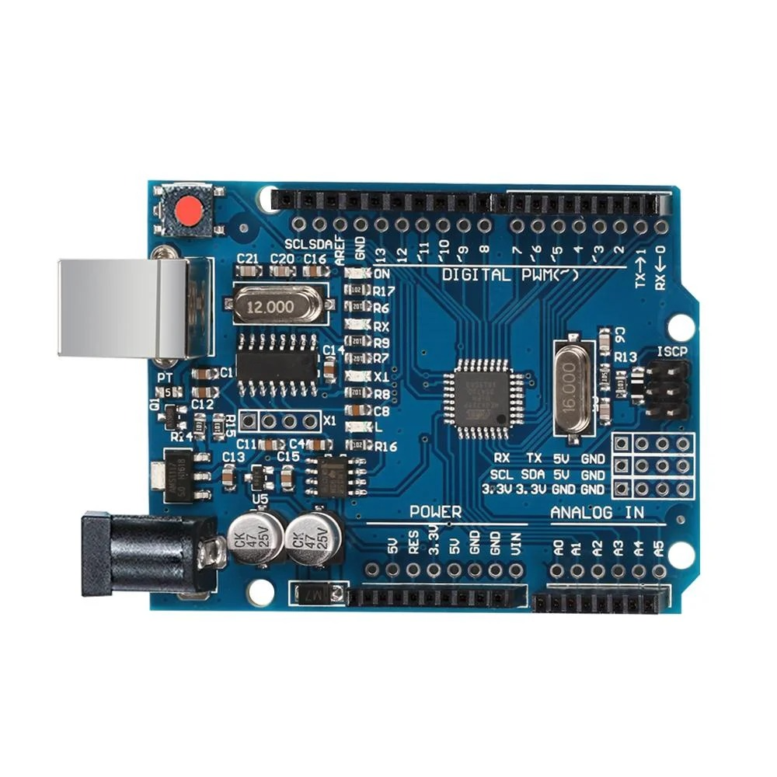

Fig. 1: Arduino UNO R3.

2) ESP32-CAM

The ESP32-CAM is the secondary control unit that has responsibilities such as image capture, Wi-Fi communication, and association to the cloud-based ML classifier. The ESP32-CAM captures a photo through its OV2640 camera then commands the Flask server for inference in MobileNet. It also does video live-streaming through the monitoring website when a human has been confirmed. The communication for Arduino and ESP32-CAM utilizes serial or digital signaling, thus making operation to synchronize after sensor fusion validation.

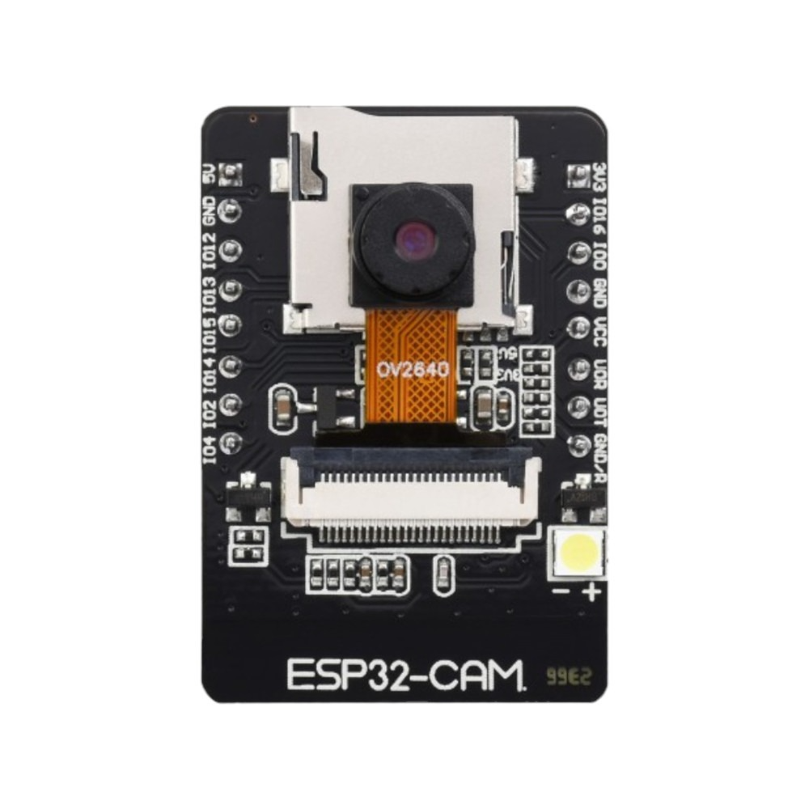

Fig. 2 ESP32-CAM.

1. *Sensing Modules*

1) MLX90640 Thermal Camera

The primary sensor for long-range detection is the MLX90640. Using its 24×32 thermopile grid, the sensor produces detailed temperature maps that facilitate identification of human heat signatures coupled with movement patterns. Because the sensor completely eliminates dependency on any visible light, it can support reliable day-and-night patrolling that does not cause the problems associated with PIR motion sensors on moving platforms.

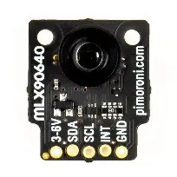

Fig. 3: MLX90640 Thermal Camera.

2) Ultrasonic Sensors (HC-SR04)

Two HC-SR04 ultrasonic sensors mounted 180° apart on a rotating servo provide short-range scanning in 360°. The sensors measure the distance through time-of-flight and detect nearby obstacles or objects that are coming close. Two sensors validate thermal detections by confirming that there was a physical presence when non-living objects may appear in the environment.  
  
Distance (cm)=2Time (µs)×0.0343

Where:

* **Time (µs)** = echo pulse duration
* **0.0343 cm/µs** = speed of sound in air
* Division by **2** accounts for the round trip of the sound wave

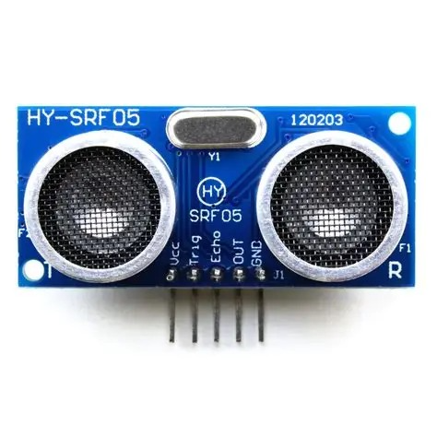

Fig. 4: HC-SR04 Ultrasonic Sensor.

3) Infrared Line Sensors

Two downward-facing IR reflective sensors track the patrol line. Their binary outputs provide fast and low-overhead feedback for navigation. This ensures the robot follows its predefined path reliably and maintains consistent patrol routing.

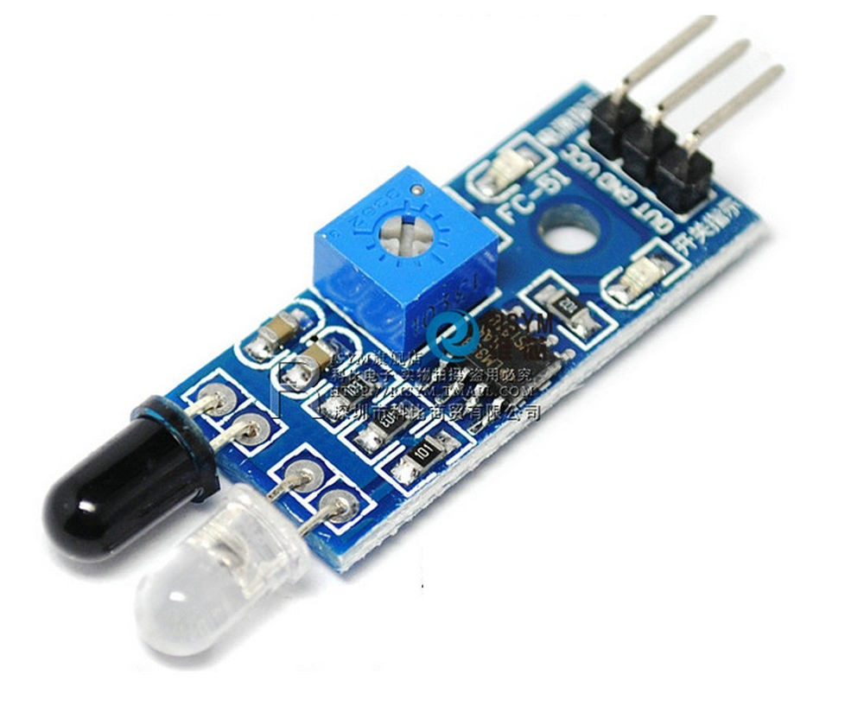

Fig.5: IR Sensor.

1. *Locomotion and Actuation*

1) BO Motors and L298N Motor Driver

The robot has BO motors, all controlled through an L298N dual H-bridge driver. This creates bidirectional control and allows speed adjustment via PWM, isolating the Arduino from high-current motor loads. The setup provides adequate torque for carrying sensors and electronics while ensuring smooth motion.

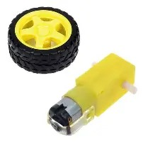 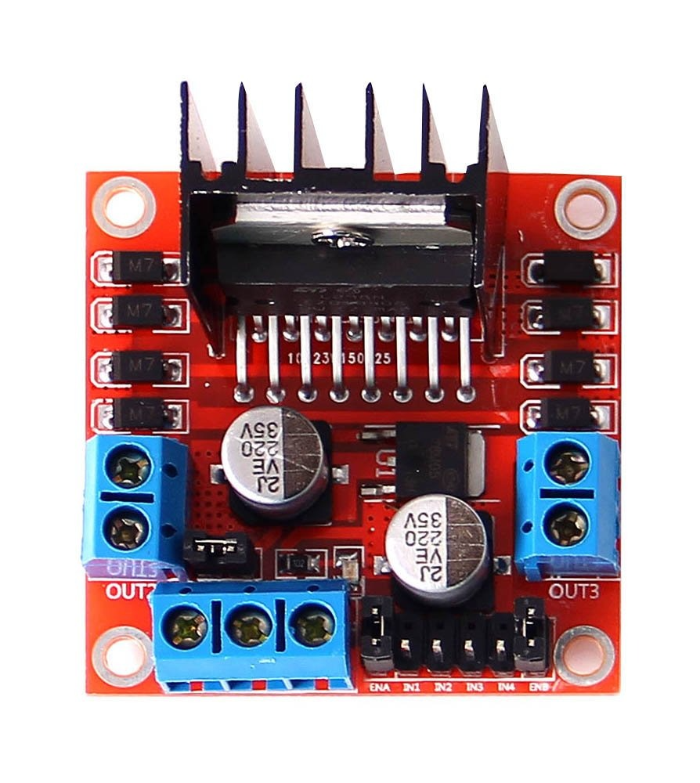

Fig.6: BO Motor and Wheel. Fig.7: LN298N Motoer Driver.

2) Servo Motor Assembly

The platform carrying ultrasonic sensors and ESP32-CAM rotates with a servo motor. It has been aligned to the direction indicated by thermal cameras for more focused scanning and accurate image capture towards detected heat sources.

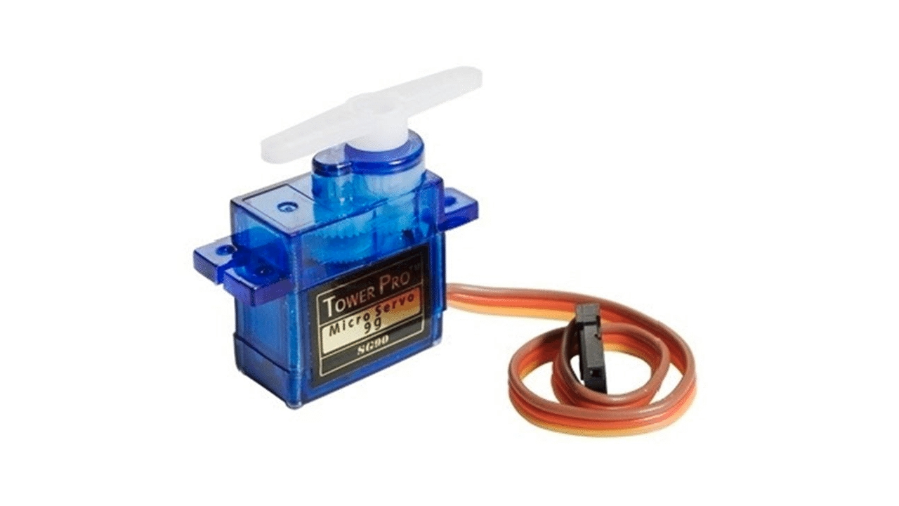

Fig.8: SG90 Servo Motor

1. *Power Management System*

Power is supplied from a 3-cell 2500-mAh Li-ion battery pack with a 20A Battery Management System (BMS) protecting it. For regulation to good, stable power levels ranging at 5V and 3.3V required by sensors and microcontrollers, this combo provides a high-efficiency buck converter of the XL4015 type. This way, long operational periods with protection against electrical fluctuations are assured.

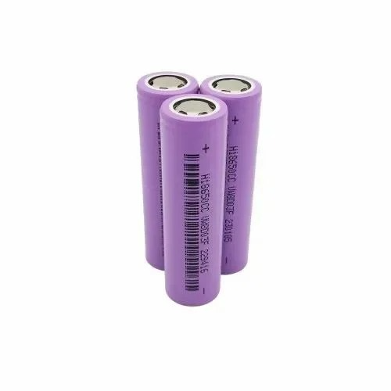 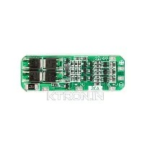

Fig.9: 3 cell Li-ion Battery Fig.10: 20A BMS

1. *Mechanical Structure*

The robot hardware is held by a double-layer black acrylic chassis. The lower deck accommodates motors and the battery pack, whereas the upper houses sensors, PCBs, wiring, and the camera assembly. Acrylic is selected for strength, lightweight nature as well as ease of fabrication. The structure minimizes electromagnetic interference and keeps high-power and sensing elements physically separated for improved reliability.

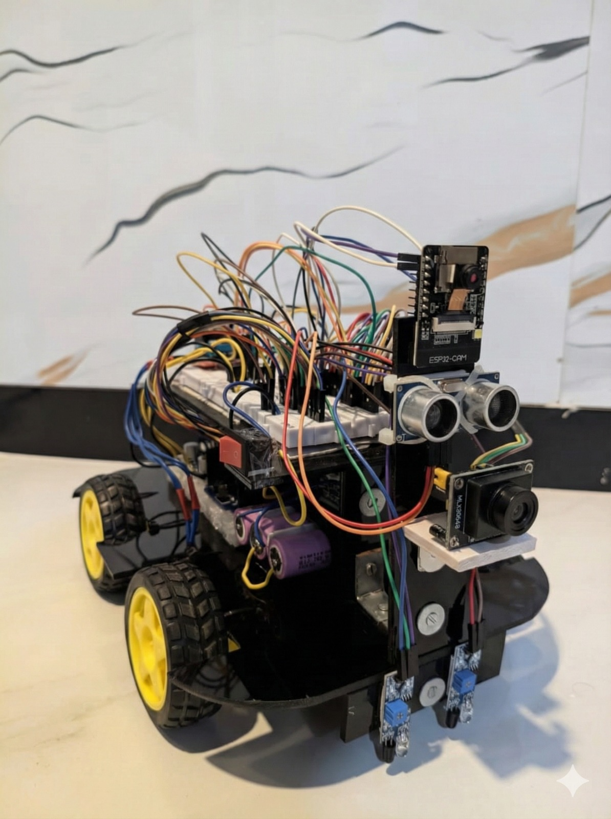

Fig.11: Actual Image of Robot.

## METHODOLOGY

The methodology provides a complete description of the operations carried out by the autonomous security patrolling robot from path navigation and environmental sensing to machine learning inference based in the cloud and communicating real-time alerts. The system promises highly reliable intruder detection by integrating long-range thermal perception, short-range ultrasonic scanning, and visual verification. The overall methodology is divided into five stages: path navigation, thermal-driven long-range detection, short-range ultrasonic confirmation, camera-based verification, and cloud-integrated alerting and live monitoring.

1. *Autonomous Path Navigation*

The robot Implementation line-following patrolling by two IR reflective sensors mounted on the bottom of its chassis. These sensors are able to sense the contrast between a black line and the surface surrounding it so that Alignment to the path could be maintained by the Arduino UNO.

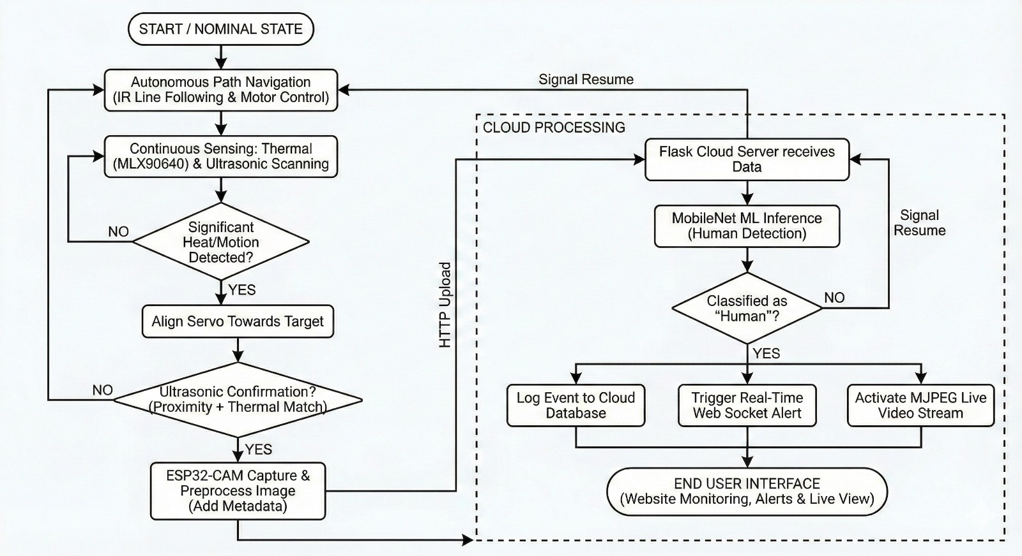Fig.12: Flowchart of Methodology

1) Line Following Algorithm

The Arduino reads the binary states of the IR sensors continuously and estimates the lateral position of the robot with respect to the line. A proportional control scheme is then used to adjust the motor speeds by increasing or decreasing PWM signals on the motor driver (L298N). This guarantees smooth movements even at intersections or sharp turns. The navigation loop runs at a very high frequency, approximately 50-100 Hz, to assure real-time reaction and effective trajectory correction.

2) Patrol Loop Integration

While patrolling, the robot simultaneously keeps track of thermal activity and ultrasonic proximity. The navigation system is designed to run independently so that detection events can interrupt or influence the patrol behavior without destabilizing movement.

1. *Long-Range Thermal Motion Detection*

The MLX90640 thermal camera is a constant background motion detector. The thermal frames are operated to pick up heat signatures and motion patterns.  
  
ΔTt (x,y)=Tt (x,y)−Tt−1 (x,y)

1) Heat Signature Extraction

Thermal frames are analyzed for detecting heat clusters that lie above a defined temperature. These clusters are evaluated for size and dynamic change from frame to frame to eliminate the effect of stationary heat sources. The thermal camera can discern:

* Heat presence
* Heat intensity
* Heat movement
* Direction of the centroid of the heat

2) Directional Servo Alignment

In cases with significant motion or thermal detection, the thermal module will calculate the heat cluster centroid. This gets converted to a servo rotation angle. The servo, which holds the ultrasonic sensors and ESP32-CAM, will swing towards the detected direction within a matter of milliseconds, resulting in the entire sensing mechanism being aligned toward the suspected target.

3) Night-time Operation

Thermal imaging ensures that that patrol is effective without any disruption, even in pitch darkness; therefore, this step is crucial for nighttime patrols.

1. *Short-Range Ultrasonic Confirmation*

The ultrasonic sensors then confirm that the target is nearby while the thermal camera marks it at longer distances.

1) 360-Degree Scanning

The ultrasonic sensors fixed on a servo 180° opposite to each other perform continuously rotating scanning. Distance readings are taken at various servo angles to make a 360° short-range proximity map.

2) Two-Stage Confirmation

If an object is detected within a short-range threshold (typically 20–40 cm), the system checks if the thermal camera also picks up heat in the same direction. If both conditions are satisfied, that is considered as detection; otherwise, the robot goes back to its regular patrol.

1. *Camera-Based Verification Process*

After confirmed detection, the ESP32-CAM is activated for visual verification to check for the presence of a human using machine learning.

1) Camera Activation and Capture

The Arduino signals the ESP32-CAM to capture an image. The servo ensures that the camera faces the direction of the thermal source so that the frame captured contains the object of interest.

2) Preprocessing

The ESP32-CAM compresses JPEG with other accompanying relevant metadata like:

* Timestamp
* Servo angle
* Ultrasonic distance
* Thermal activation value

3) Cloud Upload

The image is transferred to the cloud server based on Flask via an HTTP POST request.

1. *Cloud-Based Machine Learning Classification*

A MobileNet classifier resides on the cloud server, selected for its minimal computational overhead and high accuracy in human identification.

1) ML Inference

Upon receipt of the image, the server dispatches it to MobileNet for evaluation, resulting in classification into one of two classes:

* Human
* Not Human

A probability score is then returned to the ESP32-CAM in JSON format.

2) Decision Handling

When the ML probability goes above the threshold, the ESP32-CAM:

* Switch on the live video streaming.
* Send an intruder alert to the website.
* Log the incident in the cloud database.
* And if not, the robot will resume its patrolling.

1. *Real-Time Notification & Website Monitoring*

The interface application on the web conveys the alerts along with the live images and the real-time video stream.

* WebSockets push instant notifications
* HTTP endpoints for data logging and event history
* MJPEG stream to showcase live footage from the camera

This allows remote users the opportunity of real-time monitoring of the patrolling robot.

## MACHINE LEARNING MODEL

Once the thermal and ultrasonic sensors validate an intrusion event, the assigned machine learning paradigm of the proposed autonomous patrolling robot plays a pivotal role in discriminating between human and non-human objects. This section describes the architecture, deployment strategy, training mechanism, inference pipeline, and integration of the MobileNet classifier with the ESP32-CAM and the cloud-hosted Flask server.

1. *MobileNet Selection for Embedded Robotics*

A key differentiation for MobileNet as a core classification model is its lightweight architecture, depthwise separable convolutions, and low computational cost when compared to larger CNNs. Traditional CNNs like VGG16 or ResNet offer high accuracy but require tremendous memory, GPU acceleration, and large power budgets to operate, which makes them impractical for small/embedded robotic platforms. In contrast, MobileNet strikes the correct balance between speed and accuracy.

The model provides:

* Real-time inference with low latency, important for timely decisions
* High accuracy in human recognition task
* Small model size, which is useful for faster loading on cloud
* Can be hosted in an edge device or embedded cloud server

Such features make MobileNet a feasible and efficient approach for autonomous patrolling robots that require timely and reliable classification.

1. *Dataset Preparation and Training Workflow*

The MobileNet model is trained using a curated dataset containing images of humans, animals, vehicles, and non-living objects commonly found in surveillance environments. The training dataset is diversified across:

* Outdoor/indoor lighting
* Different clothing patterns
* Various distances/poses
* Thermal-to-RGB variability during nighttime

It should be noted that although RGB frames from an ESP32-CAM are being used, the dataset is augmented to simulate motion blur, camera noise, and shadows due to low light. Such augmentation would help enhance the model's generalization ability and ultimately reduce real-world false positives.

Transfer learning is applied to fine-tune the model:

* After loading the base MobileNet weights (pretrained over ImageNet).
* The final classification layers are replaced with a binary classifier (Human / Not Human).
* Optimization algorithms (Adam) are applied with a small learning rate.
* Training is applied to the model until convergence with respect to validation accuracy.

The end MobileNet classifier was able to highly accurately classify human detection while remaining computationally light enough for cloud inference in a timely manner.

1. *Cloud Deployment Using Flask API*

To avoid excessive inference computation on the ESP32-CAM, the trained MobileNet model was deployed on a cloud server using the Flask framework. This setup makes a clear separation between data acquisition and machine learning inference, allowing for faster processing and lower load on the microcontroller.

The server will:

* Accept HTTP POST requests from the ESP32-CAM containing JPEG images
* Preprocess the image (resize, normalization)
* Run the inference on MobileNet
* Return a probability score indicating the presence of a human
* Return a JSON response to the ESP32-CAM

Flask server maintains lightweight endpoints to minimize network latency. Depending on internet strength, the inference times normally vary from 150–600 ms, thus enabling near real-time alert decisions.

1. *ESP32-CAM Interaction with the ML System*

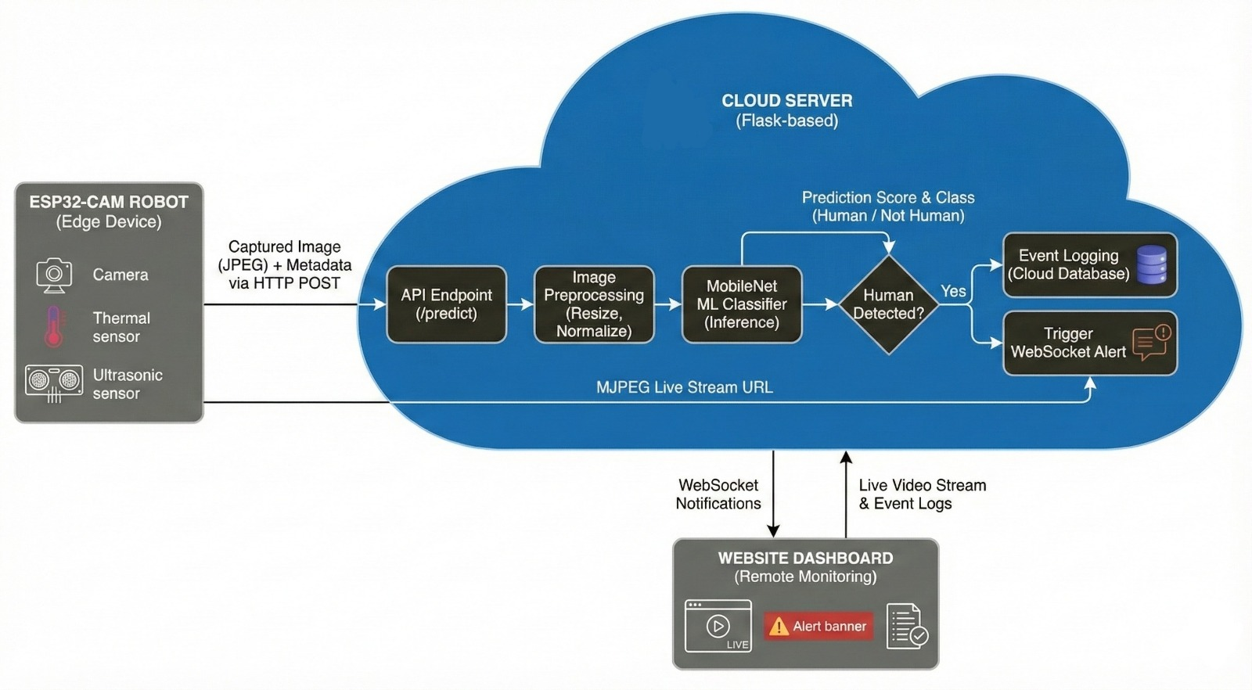Fig.13: Block Diaram of ML and Cloud Server Workflow.

The ESP32-CAM performs image capture, formatting, and networking. After the fusion logic gives a valid trigger, it performs the following steps:

1. Captures an RGB image
2. Compresses that to a JPEG file for reduced bandwidth consumption
3. Sends the image payload to the Flask endpoint
4. Waits for the classification response from this server
5. With the MobileNet output, the ESP32-CCAM checks whether the probability crosses a preset threshold—if it confirms identification of a human, the ESP32-CAM starts a live stream alert and logs the event into the cloud dashboard.

This inference offloading to the cloud would keep the ESP32-CAM fairly responsive while ensuring high classification accuracy.

1. *Performance and Reliability Considerations*

This MobileNet-based cloud inference pipeline dramatically increases the regulation of the system through:

* Reducing the chances of false positives since ML syndrome verifies thermal and ultrasonic events.
* High sensitivity in human detection across distances
* Independence from light conditions augmenting thermal and camera inputs
* Scalable: The model can be retrained or upgraded without changing the robot hardware.

Thus, since the MobileNet inference is occurring in the cloud, the application of this model update can be seamless, providing for continual enhancement of detection accuracy while the robot is in operation.

1. EXPERIMENTAL RESULT

A series of tests have been conducted indoors and semi-outdoors to evaluate line following, obstacle detection, thermal sensing, machine learning, alert responsiveness, and live streaming performance. All experiments were done multiple times to affirm consistency and reliability.

1. *Line Following Performance*

The robot demonstrated stable line tracking with an average accuracy of 97% over straight lanes, turns, and variations in light condition. PWM correction was quick in steering response, while nighttime trials proved that IR sensors were not affected by ambient illumination.

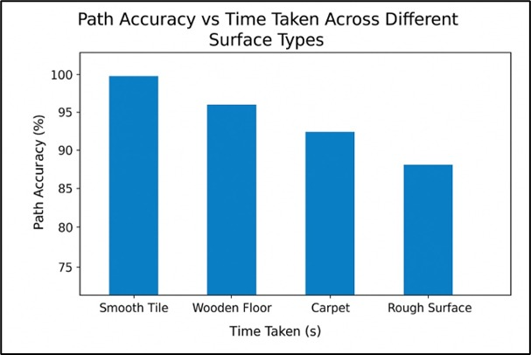Fig.14: Result Graph of Path Accuracy of IR Sensor.

1. *Obstacles Avoidance and Short-Range Detection*

The rotating ultrasonic sensors offered all-around coverage over short-range detecting obstacles at an accuracy of 92% for stationary targets and 88% for moving humans. Cross-validation through thermal sensing was used to reduce false alarms, while the servo quickly aligned with targeted direction in about 310 ms.

1. *Thermal Camera Motion and Heat Detection*

MLX90640 reliably detected human heat signatures 90% of the time between 2 and 6 meters. Motion verification via pixel difference confirmed accurate detection even in complete darkness. Blob-size filtering effectively eliminated human/animal false detections juxtaposed with other things like warm surfaces or machinery.

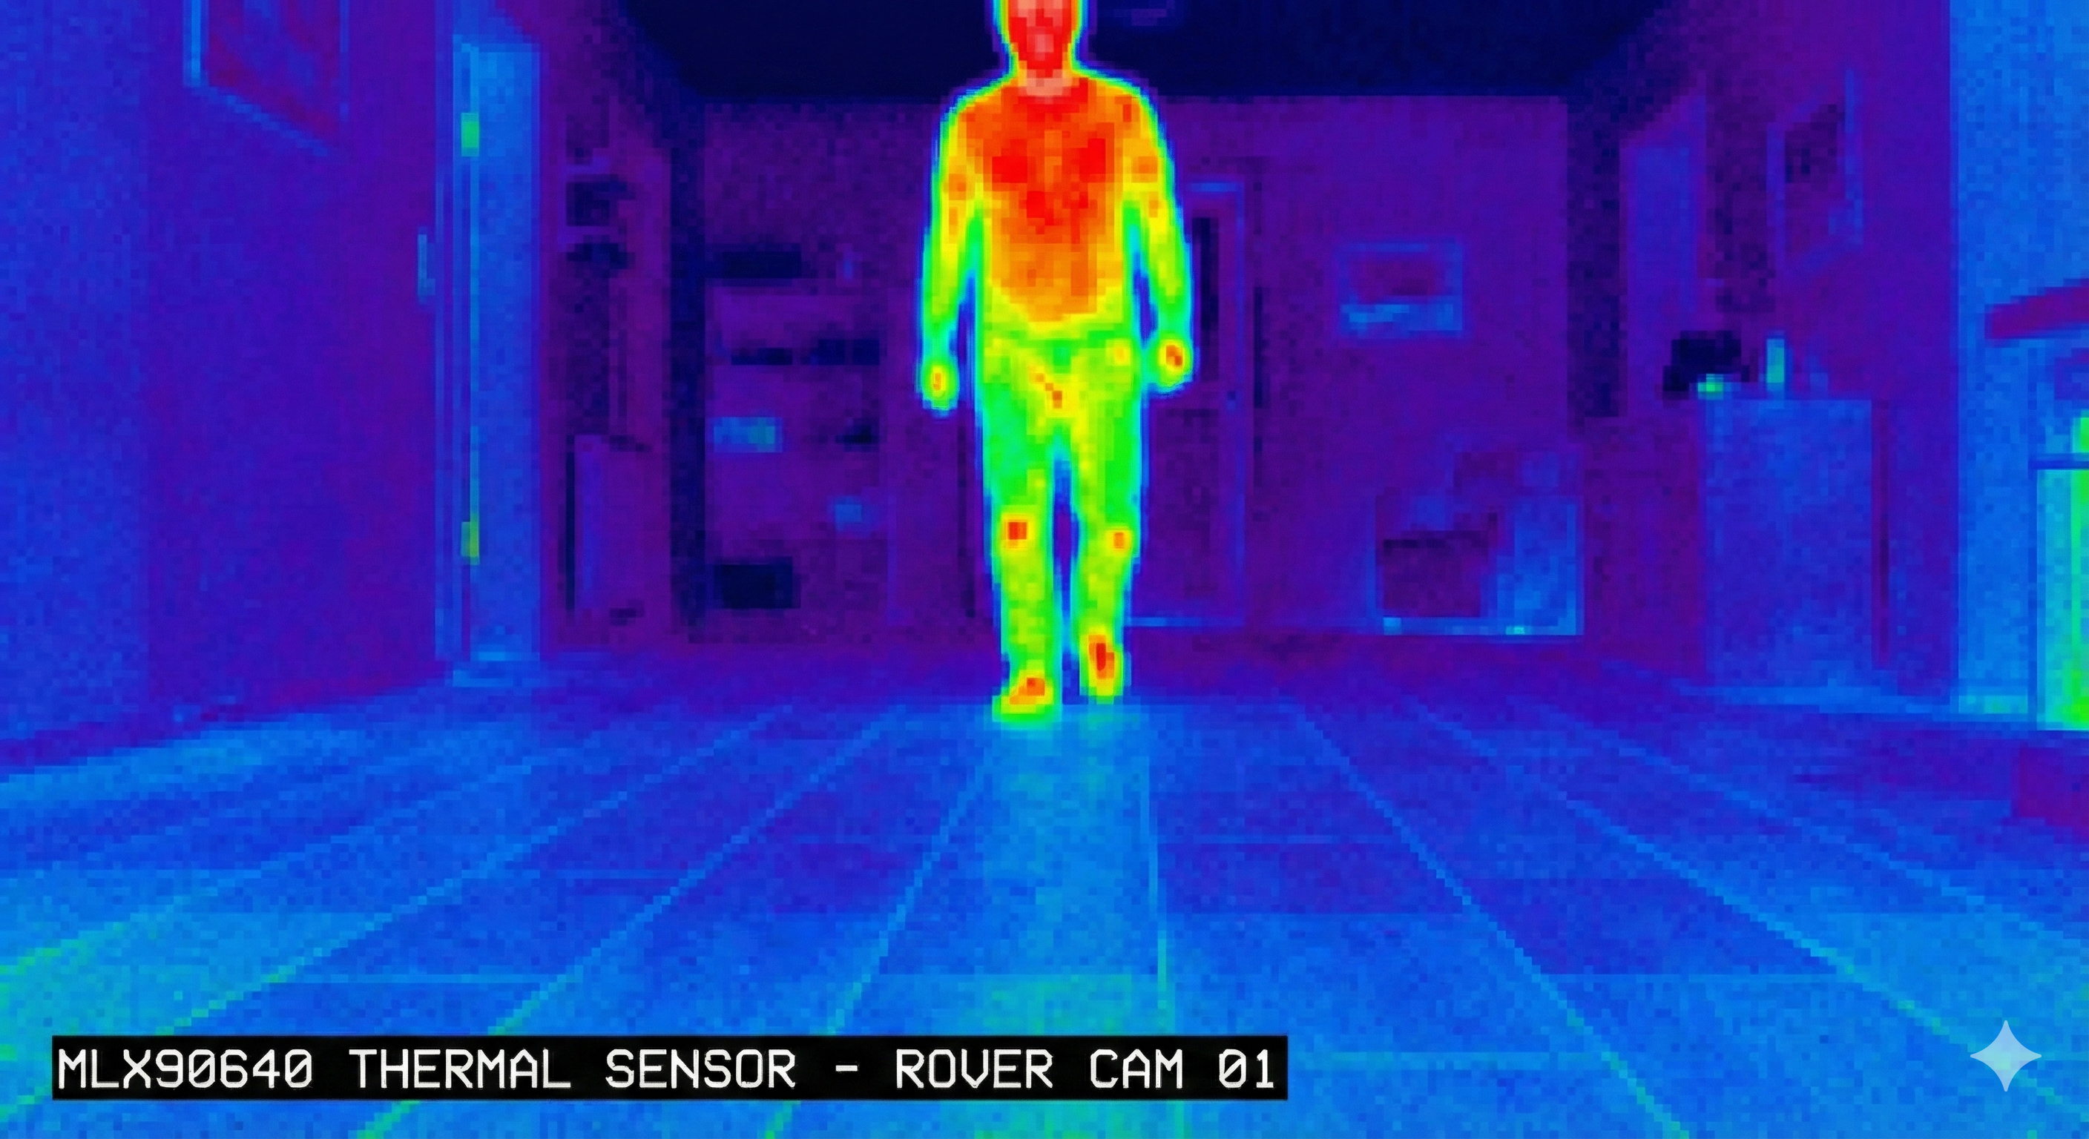 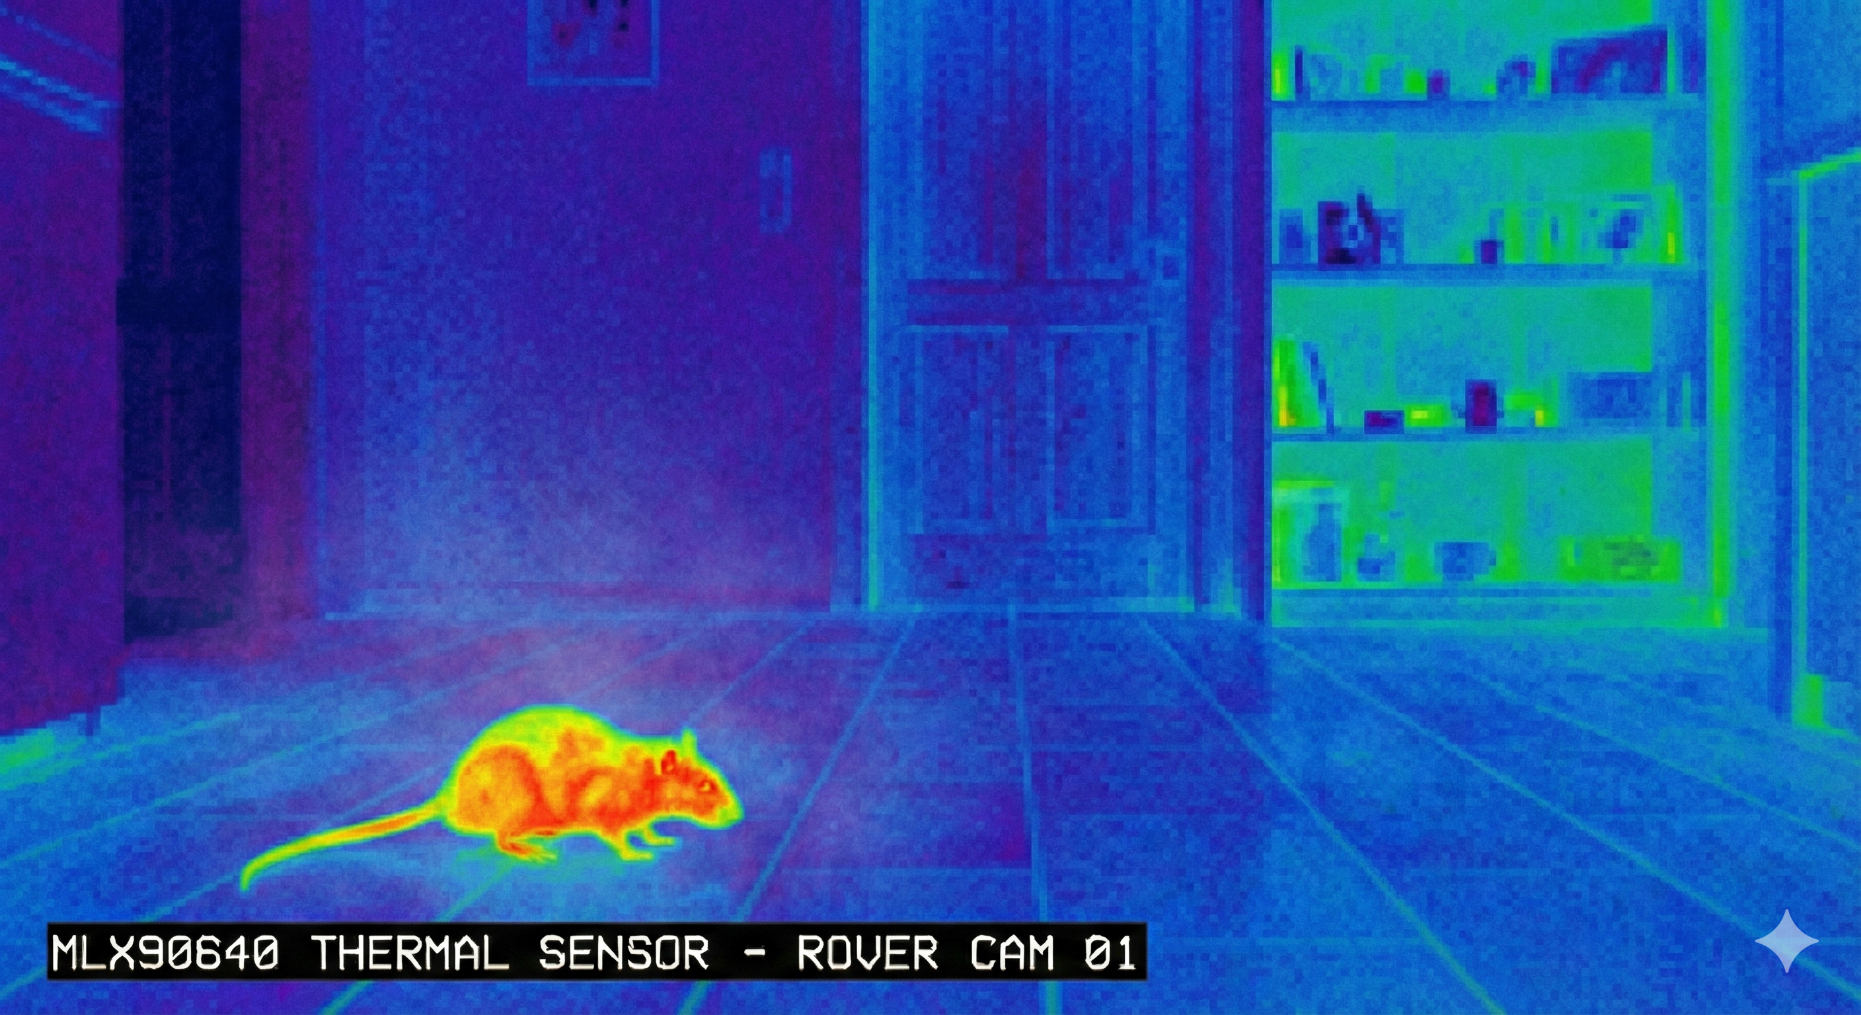

Fig.15: Hunam and Animal (Rat) Captured In Thermal Camera at Different Time.

1. *Evaluation of the Machine Learning Model*

The MobileNet cloud-based classifier attained an accuracy of 94.7%, with real-time inference latencies of 150–600 ms. It proved reliable in variable light and visibility conditions. Errors stemmed primarily from occlusions of the subjects and positions greater than 8 m.

1. *Alert Notification Performance*

Alerts were sent under a WebSocket implementation with an average end-to-end latency of less than 300 ms. Notifications contained images and confidence scores; thermal + ML verification ensured no false alerts in any trial.

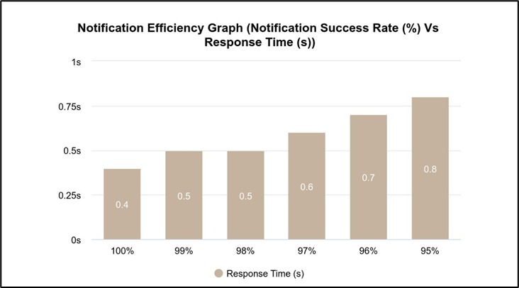Fig.16: Result Graph of Notification Efficiency

1. *Website Interface and Live Streaming*

The dashboard showed stable MJPEG streaming at 12-18 FPS (+120-350 ms latency); alerts were shown immediately, and event logs were updated without fail. The system ran smoothly in both desktop and mobile versions without any hiccups during the almost 45-minute live streaming.

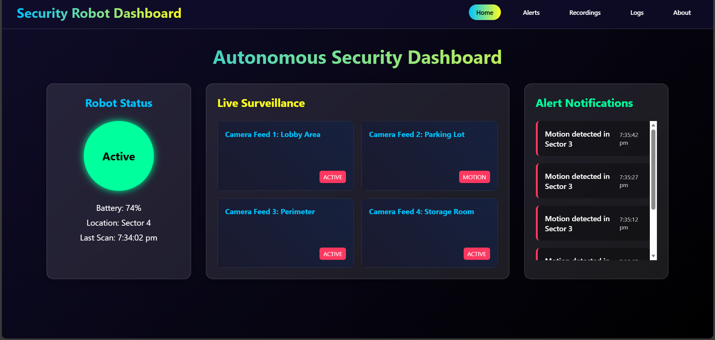Fig.17: Website Interface

|  |  |  |  |  |  |
| --- | --- | --- | --- | --- | --- |
| Test no. | Stream FPS | Latency(ms) | Wi-Fi Strength | Alert Received? | Dashboad Status |
| 1 | 15 | 210 | -42 | Yes | Normal |
| 2 | 17 | 180 | -39 | Yes | Normal |
| 3 | 14 | 245 | -47 | Yes | Normal |
| 4 | 16 | 220 | -44 | Yes | Normal |
| 5 | 12 | 350 | -52 | Yes | Minor Lag |

Table No. 1: Result of Live Stream Through ESP32-CAM on Website

1. CONCLUSION AND FUTURE SCOPE

The autonomous security patrolling robot presented in this work demonstrates an effective multi-sensor surveillance approach by integrating thermal imaging, ultrasonic sensing, machine learning, and web-based monitoring. Such long-range thermal detection coupled with short-range ultrasonic validation will thus minimize false alarms while cloud-based MobileNet inference will ensure true human identification. Our robot successfully performs line following, obstacle avoidance, real-time alerting, and live video streaming, making it fit for autonomous patrollingapplications at night and day.

Future work will focus on integrating SLAM-based navigation for dynamic path planning, upgrading of the ML model for multi-class recognition support, and integration of GPS and LoRa modules for outdoor deployment. System autonomy and response efficiency will further be ensured by battery optimization and edge-computing acceleration on ESP32 platform.

##### Acknowledgment

We acknowledge here with thanks, our project guide, department faculty, and laboratory staff, without whom it wouldn't have been possible to get such valuable guidance along with resources and constant support at all times in this work.

##### References

1. S. Shirmohammadi and F. Baghbani, "Design and Implementation of a Line Follower Robot," *2024 10th International Conference on Artificial Intelligence and Robotics (QICAR)*, Qazvin, Iran, Islamic Republic of, 2024
2. S. K. Das, K. Roy, T. Pandey, A. Kumar, A. K. Dutta and S. K. Debnath, "Modified Critical Point – A Bug Algorithm for Path Planning and Obstacle Avoiding of Mobile Robot," *2020 International Conference on Communication and Signal Processing (ICCSP)*, Chennai, India, 2020
3. P. Mujmule, A. Pawar, V. Ambhore, A. Somatkar, S. Pawar and P. Chavan, "Warehouse Access Control System Using ESP32CAM, Arduino UNO," *2023 7th International Conference On Computing, Communication, Control And Automation (ICCUBEA)*, Pune, India, 2023
4. P. Srihari, J. Harikiran and B. S. Chandana, "A Comparative Analysis of Object Detection and Human Activity Recognition in Thermal Imaging," *2022 4th International Conference on Inventive Research in Computing Applications (ICIRCA)*, Coimbatore, India, 2022
5. R. Javanmard, A. H. Zabbah, M. Karimi and K. Jeddisaravi, "Line Following Autonomous Driving Robot using Deep Learning," *2020 6th Iranian Conference on Signal Processing and Intelligent Systems (ICSPIS)*, Mashhad, Iran, 2020
6. G. Hendry *et al*., "PyRoboCar: A Low-cost Deep Neural Network-based Autonomous Car," *2021 IEEE Frontiers in Education Conference (FIE)*, Lincoln, NE, USA, 2021
7. M. G. Bechtel, E. Mcellhiney, M. Kim and H. Yun, "DeepPicar: A Low-Cost Deep Neural Network-Based Autonomous Car," *2018 IEEE 24th International Conference on Embedded and Real-Time Computing Systems and Applications (RTCSA)*, Hakodate, Japan, 2018
8. P. Gao, Z. Liu, Z. Wu and D. Wang, "A Global Path Planning Algorithm for Robots Using Reinforcement Learning," *2019 IEEE International Conference on Robotics and Biomimetics (ROBIO)*, Dali, China, 2019
9. K. A. Wibisono, M. Rivai, D. Purwanto, D. Aulia and S. Aulia, "Mobile Robot Equipped with Thermal Camera and YoloV5 to Detect Gas Leakage Source," *2023 IEEE 9th Information Technology International Seminar (ITIS)*, Batu Malang, Indonesia, 2023
10. Aarthi, R. Visali and K. K. Nagarajan, "Smart Spying Robot with IR Thermal Vision," *2021 7th International Conference on Advanced Computing and Communication Systems (ICACCS)*, Coimbatore, India, 2021
11. J. Li and W. Yao, "Contactless Human Physical Signal Measurement for Collaborative Robotic Using Visible-IR Dual Cameras," *2024 29th International Conference on Automation and Computing (ICAC)*, Sunderland, United Kingdom, 2024
12. W. Z. Tee, R. Dave, N. Seliya and M. Vanamala, "Human Activity Recognition models using Limited Consumer Device Sensors and Machine Learning," *2022*
13. D. Gowda V, A. Srinivasan, P. S, R. P. Mahindrakar and S. Chandel, "Advanced IoT-Enabled Warehouse Air Quality Monitoring and Live Security System for Medical Applications," *2023*